**Ejercicio 10**

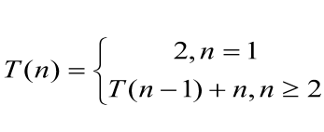

Buscamos un paso general

P1 = T(n-1) + n

P2 = T(n-2) + 2n

P3 = T(n-3) + 3n

Pi = T(n-i) + in

Buscamos caso base

n-i = 2

n = 2 + i

n - 2 = i

Reemplazamos por el caso base

Pn-2 = T(n-(n-2)) + (n-2)n

= 2 + n2 n-2

= O(n2)

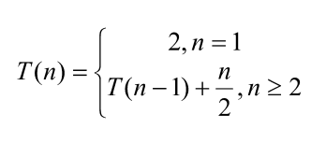

Completar

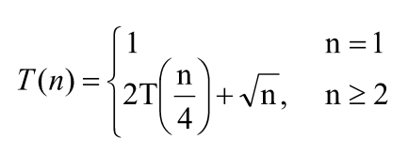

Completar

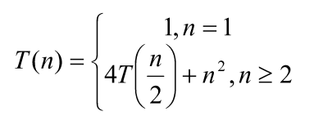

Buscamos un paso general

P1 = 4T() + n2

P2 = 4[4t(/2) + ()2] + n2 = 16T(= 16T( $\frac{n}{4})$ + 2n²

P3 = 16[4t( $\frac{n}{4}/2)$ + ( $\frac{n}{4})²] + 2n²$ = 64T($\frac{n}{8}) + 16(\frac{n}{4})² + 2n² = 64T(\frac{n}{8})+3n²$

Pi = 4iT($\frac{n}{2¹}) + in²$

Reemplazar por el caso base

$\frac{n}{2¹} = 1 (2¹ = 2i )$

n = 2i

log2(n) = log2(i)

i = log2(n)

4log2(n) T(

² = n² + log2(n) n2 = O(log2(n) n²